**Article 1**

**Winner of the GOURMAND WORLD COOKBOOK AWARDS 2014, Best Easy Recipes Book from Australia**

**At home with Sous vide by Dale Prentice**

Sous Vide: A New Approach to Cooking

At Home with Sous Vide celebrates the gentle art of low-temperature cooking. Discover the way an exact approach to cooking can transform food, and the incredible flavour and texture that can be achieved when cooking meat, fish, eggs, vegetables and even fruit sous vide.

Director of Sous Vide Australia, teacher and chef, Dale Prentice provides 74 easy-to-follow recipes, including 37 dishes from some of the world’s most renowned chefs, restaurants and sous vide enthusiasts. Each recipe is beautifully photographed and broken down into step-by-step components.

From simple salads to easy dinner recipes for beginners to more elaborate dishes for the confident cook, At Home with

Sous Vide takes this amazing new style of cooking out of the restaurant world and into the home.

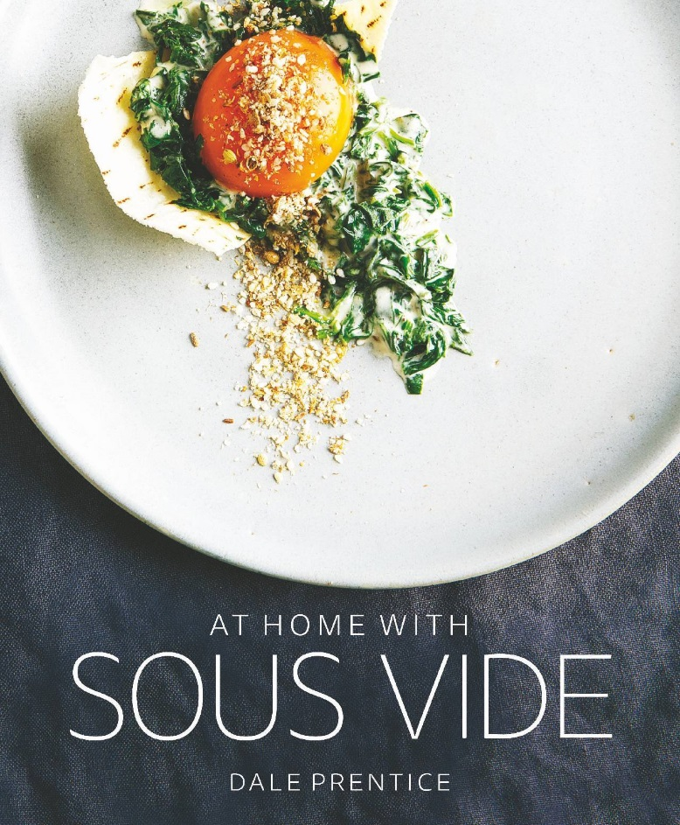

The author Dale Prentice trained as a chef in Melbourne, Australia, having worked in many venues in his 17 years at the pass. In his last role as executive chef at Stones of the Yarra Valley, he shared his kitchen with many renowned chefs—including Greg Malouf, Philippe Mouchel, Frank Camorra, George Calombaris and Riccardo Momesso. It was at Stones of the Yarra Valley that he first implemented sous vide cooking as a way of expanding the existing kitchen. After only a short period, Dale became obsessed with sous vide and the benefits it brought to a commercial kitchen. Sous Vide Australia grew out of this passion and a need to share these amazing benefits with everyone he knew. Since 2009, Sous Vide Australia has grown rapidly and Dale is often asked to give lectures and training in sous vide cooking and equipment all over Australia.

Contributors to this book Include:

Shannon Bennett, Melbourne

James Blight, Melbourne

Madalene Bonvini-Hamel, London

Marsha Busse, Melbourne

Raymond Capaldi, Melbourne

Ryan Clift, Singapore

Roberto Cortez, Washington

Stefan Cosser, London

Kerby Craig, Sydney

Dallas Cuddy, Singapore

Patrick Dang, China

Andrew Dargue, London

George Diamond, Sydney

Adam Draper and Emma D’Alessandro, Melbourne

Wylie Dufresne, New York

Mark Ebbels, Singapore

Brad Farmerie, New York

Harold Fleming, Brisbane

Anthony Fullerton, Brisbane

Florent Gerardin, Melbourne

Bruno Goussault, USA

Jarrod Hudson, Melbourne

Jason Logsdon, Connecticut

J. Kenji López-Alt, New York

Christine Manfield, Sydney

Garen Maskal, Melbourne

Philippe Mouchel, Melbourne

Nathan Myhrvold , Washington

Spencer Patrick, Port Douglas

Darren Purchese, Melbourne

Tom Randolph, Perth

David Roberts, Melbourne

Michael Ryan, Beechworth

Wayne Smith, Tasmania

Joe Strybel, Illinois

Pablo Tordesillas, Brisbane

At home with sous vide is available online at [www.homesousvide.com.au](http://www.homesousvide.com.au) or in many specialty cookbook stores.